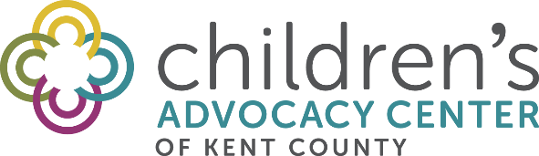

Dear Parents and Guardians,

The Children’s Advocacy Center of Kent County offers the body safety program, Kids Have Rights®, to students in kindergarten through 4th grade throughout Kent County. The Kids Have Rights® curriculum incorporates information on:

- The “Rights” all kids have to keep themselves safe.
- Identifying the safe adults in a child’s life they can go to if they need help.
- Recognizing different kinds of touches.

The Kids Have Rights® classroom lessons are led by staff of the Children’s Advocacy Center. These lessons are engaging, child-centered, and age appropriate body safety knowledge for children.

- Kindergarten and 1st grade students participate in a 15 minute program that combines movement with learning. They identify safe adults in their lives and three different kinds of touches.

- 2nd graders watch a 3 minute video about the six “rights” kids have, complete an activity about safe adults, as well as discuss the three different kinds of touches.

- 3rd grade students also watch the 3 minute video about the six “rights”, complete an activity about safe adults, and watch a 8 minute video followed by a discussion identifying important concepts in the stories they viewed.

- 4th grade students expand their knowledge on the “rights” all kids have by watching a 3 minute “Rights and Responsibilities” video. The Educator then review qualities of a safe adults, and the three types of touch. They then view a 5 minute video followed by a discussion highlighting the key concepts observed in the story viewed.

The day of your child’s classroom lesson, a Kids Have Rights® brochure for parents and caregivers will come home with information on body safety education and prevention.

In addition, three worksheets will come home with your child at two week intervals to help reinforce the key concepts taught. Please review these worksheets with your child, read the information on the back and complete the parent/child activity.

Lastly, there will be an evaluation for you to complete.

If you would like your child excluded from the program please contact your child’s school.

If you have any questions please contact your child’s school or visit our website for more information:
https://cac-kent.org/our-services/kids-have-rights/

